World Mission
@ St. Patrick’s Wallington


Jesus said, ‘Go into all the world and
preach the gospel to all creation’
Mark 16.15

Contents

 | Page
Full time Mission Partners
Andrew & Lisa Peart (CMS, Bolivia) | 3
International Needs | 4
Jo Plummer (BAM Global / YWAM) | 5
Joe & Rachel Clarke (Crosslinks, Portugal) | 6
Open Doors | 7
Pastor Daniel (SEAN/ TEE Uganda) | 8
pro DEO Church, Romania | 9
Study by Extension to All Nations (SEAN) | 10
Sutton Schools Work | 11
Others working in Mission
Paul | 12



Andrew and Lisa Peart
Working with Cristo Luz del Mundo Church, Santa Cruz Bolivia
Church Mission Society

Partnering with the local church to engage with the community in pioneering mission through generous, creative hospitality.

As mission partners with CMS in Bolivia for the last 6 years, we work alongside the local church in Santa Cruz. With a passion for building community, and our background in business and hospitality, we aim to use these skills to help build up the capacity of the church, by reaching out to those around us, connecting with local businesses and the surrounding neighbourhoods through initiatives like the church community garden -a tranquil space in the midst of the busy city where people can connect with each other and the Lord. Our microfinance ministry exists to give people tools to improve their finances through financial education, community savings groups, while we invest in financial and spiritual wellbeing through discipleship and fellowship. Richard and Yenni, a couple from one of the small businesses we’ve invested in, now minister to others who have lived challenging lives on the streets in their local community, offering a free monthly lunch for 70 people and a weekly bible study. It’s so encouraging to see how God has used this investment for his Glory as Richard and Yenni reach out to love and disciple others in Christ’s name.
Andrew has recently teamed up with a well-respected Bolivian economist to offer financial stewardship workshops to the church and local community. He is also working closely with the Bishop of Bolivia, supporting the Bolivian Diocese to develop streams of income to secure long-term financial sustainability.

Please pray for Bolivia amid the current financial crisis, especially as we head into Presidential elections in August. Please pray for us as we support our brothers and sisters in Christ through this crisis, that we would continue to share the hope and light of Christ where it is needed most to those who don’t yet know him.
Thank you for your partnership in the Gospel, St Pats!

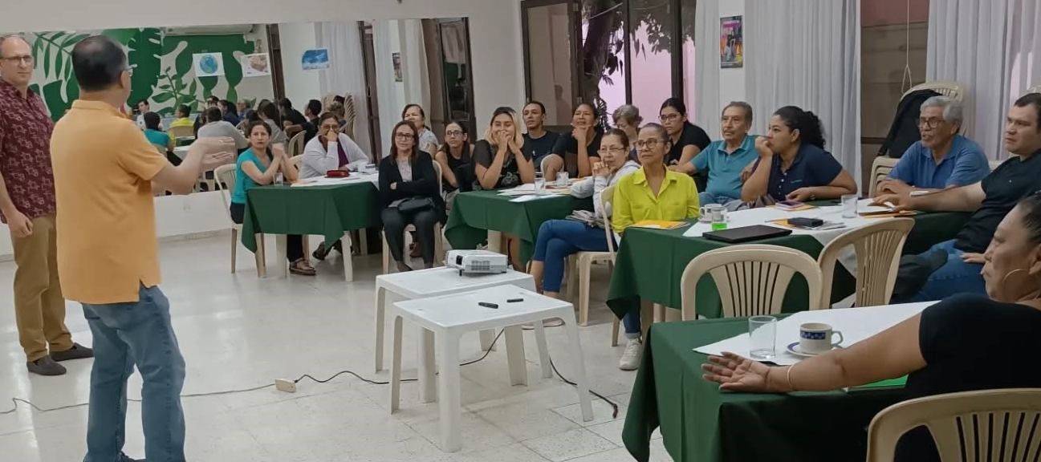

Andrew and Pablo leading a financial stewardship course in our church Cristo Luz del Mundo


We partner with local leaders worldwide to implement Christ-centred projects that improve the lives of families and offer them a sustainable future.
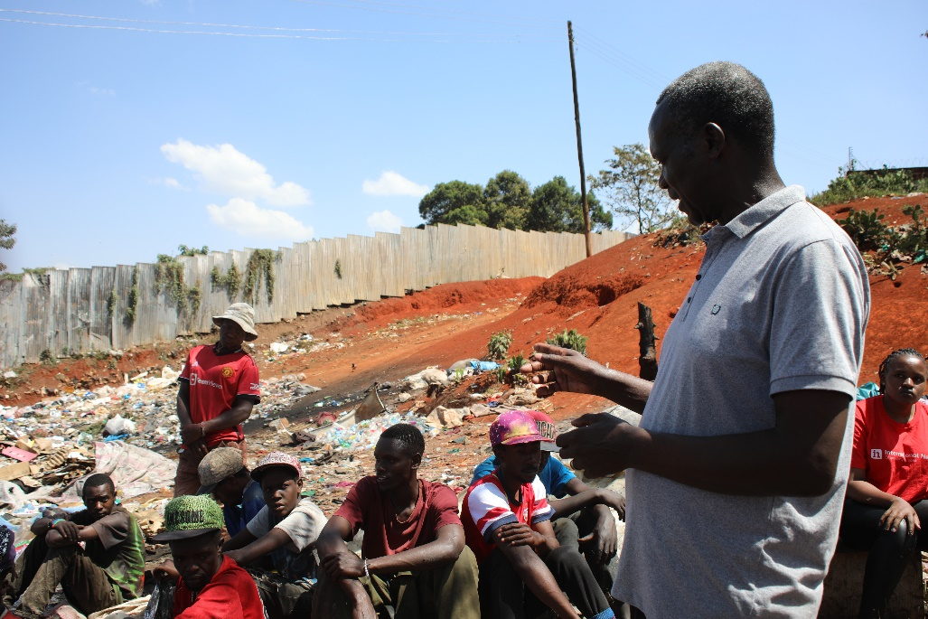
Currently, an estimated 60,000 young people are living on the streets in Nairobi, often due to abandonment, domestic violence, or extreme poverty. These harsh conditions leave them vulnerable to exploitation and addiction.

Pastor Joshua’s mission is to reach these young individuals with the Gospel of Jesus Christ, offering them a way out of their desperate situation. Through a comprehensive three-month rehabilitation program, he not only helps them recover but also supports them in developing business plans to ensure they can achieve long-term financial stability.

In November 2023, Pastor Joshua visited St. Pat’s to share his vision for a Leadership and Talent Centre. This Centre will initially provide a home and support for up to 25 boys at a time, with plans to impact over 100 boys over the next five years. The Centre will offer vocational training in areas like business management, group discussions, and creative outlets, all while continuing to provide rehabilitation from the harsh realities of street life.

We’re thrilled that having bought and fenced the land with your help; construction is beginning this year! Let’s continue this journey together!

We are deeply grateful for the partnership between St. Pat’s and this transformative work. Thank you for your continued support!
________________________________________

Prayer Points:

- Give thanks for Pastor Joshua and the entire IN Kenya team for their dedication, hard work, and unwavering commitment to transforming the lives of these young people.
- Pray that more young people come to know and trust in the Lord Jesus, embracing His saving grace.
- Pray for generous hearts among those supporting Pastor Joshua’s work and the construction of the Leadership and Talent Centre.

To find out more go to www.ineeds.org.uk or get in touch inuk@ineeds.org.uk
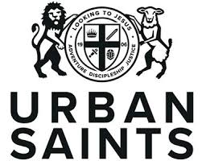

Mark & Jo Plummer
Working in West Sussex, UK with
BAM Global / YWAM & Urban Saints
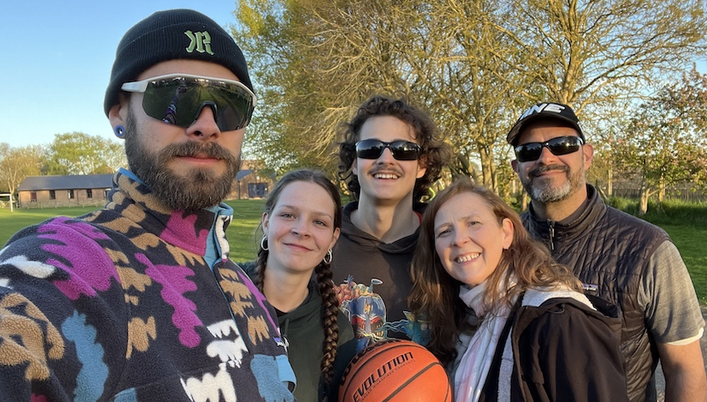
Thank you for your support and prayers!
We’re both involved in creative ways to do mission, in different roles. Jo continues to be seconded from Youth With a Mission (YWAM) to lead the global Business as Mission (BAM) network under the umbrella of BAM Global and the Lausanne Movement. Mark started a new role as Head of Operations with Urban Saints in July.
Jack (25), Evie (17), Ed (23) Jo & Mark

Missions through Business
In many parts of the world, the hardest places to reach with the gospel are also places where dire poverty, exploitation and environmental degradation are rife. The people there need to hear about Jesus, but they often also need a good job. Business as Mission is a way to meet people’s economic, environmental and social needs, alongside their spiritual needs. It’s a strategy that is often being used in global mission today – whether it’s church planting in unreached parts of North India, working with ex-convicts in Colorado, or employing human trafficking victims in Nepal. Jo’s role is helping to equip and support those doing BAM work on the frontlines.
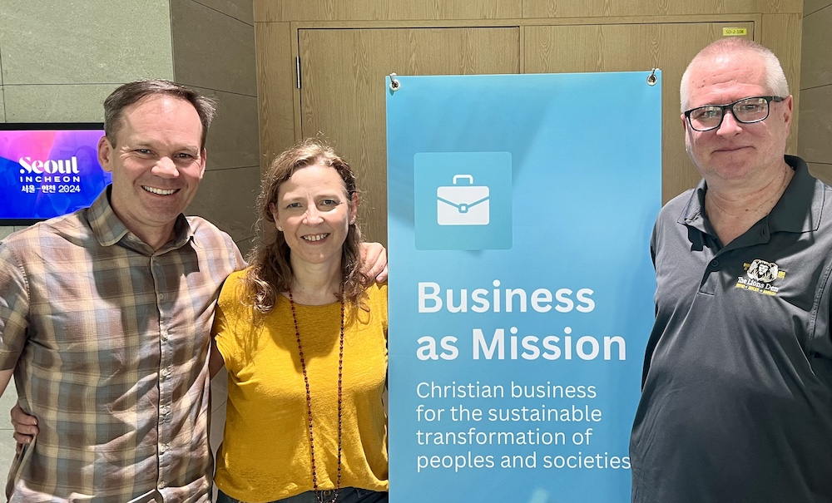
Here’s what a BAM worker said after BAM Global’s recent online Summit: “Thank you so much for this important resource. I have been so blessed by it. We have felt so alone here in northern Thailand but this Summit has given me a sense of belonging that I will share with my team.” This is what the mission of BAM Global is all about. We want to multiply business as mission around the world, by mobilising more people to go and then helping them thrive in their work. We do that by creating opportunities for them to connect with critical resources and networks.
We also create new resources where there are gaps in know-how, help new regional BAM networks get started, facilitate a BAM prayer network, publish regularly on business as mission and host a secure online community for BAMers.
Mark has been supporting Urban Saints, in his Operations role, through a series of major organisational transitions in this past year, to help them be sustainable for long-term service to young people in the UK.
Jo co-leading the Lausanne Movement’s BAM Issue Network at the Fourth Lausanne Congress

We’d appreciate your prayers for wisdom and stamina in our leadership roles.

Browse: urbansaints.org / bamglobal.org / businessasmission.com

Joe and Rachel Clarke
Working in Coimbra, Portugal with
Crosslinks
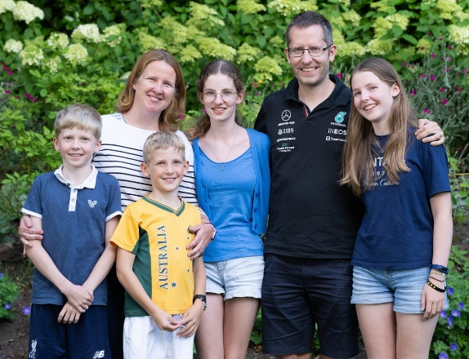
Church-planting
We are mission partners with Crosslinks, an Anglican mission society committed to bringing God’s Word to God’s world. Since January 2023, we have been involved in church planting in Coimbra, Portugal, aiming to reach the lost with the good news of the gospel and see a healthy, Bible-teaching church established in the city centre, one that makes disciples who are rooted in God’s Word and passionate for His glory.

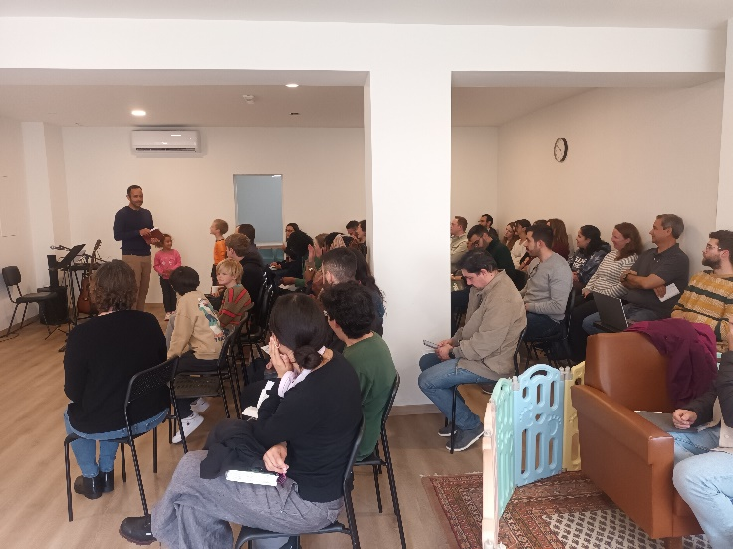
Over this past year, CGC (the church plant) has been a huge encouragement. Most weeks, we have welcomed visitors, some of whom have just moved to the area and are looking for a church to join, whilst others have come along as a result of being invited by a Christian friend. One visitor hadn’t stepped foot inside a church for twelve years due to a very bad experience in a prosperity-gospel preaching church which nearly destroyed her faith. However, when a friend invited her along, she found herself accepting the invite and is now a regular! Another more elderly lady started coming due to a “chance” meeting with our family in the street which began with her asking us about our kids and ended up with her accepting an invitation to church. And another person started visiting us, having been recently converted online(!) and longing to find a church that faithfully taught God’s Word.
CGC

Of course, there continue to be many challenges and needs – there aren’t enough leaders for all the small groups, there are some complex pastoral situations which require a lot of time and wisdom (two things that I often lack), and the space we rent for the church is getting too small (what a great problem, though!). Yet as we look back at the past year, our hearts are overflowing with thankfulness and joy for all that God has done!

As always, we are so very thankful to God for your prayers and for your continued support, which we so dearly appreciate!

Please do praise God for all who heard the gospel this year in Coimbra and pray that many would come to know and trust in Jesus for themselves. Pray especially for CGC, that the Lord might use this new community to strengthen his people and to bring others in. Pray too that over time, we wouldn’t lose our evangelistic zeal!
www.crosslinks.org



Supporting and Strengthening the Persecuted Church
Every day millions of Christians risk their lives to follow Jesus. For 70 years Open Doors has stood with those who are most persecuted; Christians around the world who share our faith but not our freedom.
In more than 70 countries, Open Doors supports our persecuted church family by supplying Bibles, providing emergency relief, trauma care and helping persecuted believers to stand strong for the long-term so that they can continue to share the hope of the gospel in challenging places.
Strong Church - We believe that there is one church and as Paul puts in 1 Corinthians 12:26, “if one part suffers, all the parts suffer with it.” It is our responsibility as Christians in the UK to stand with our brothers and sisters, through our giving our action and our prayer.
Defying Persecution- Over 380 million Christians face high or extreme levels of persecution and we want to strengthen them to keep following Christ, to defy persecution in sharing light in the darkness. Brother Andrew the founder of Open Doors once said “The greater the darkness the brighter your little light can shine.”
This is only possible with your prayer and support. Thank you so much for your care and love for our persecuted church family, I was recently in North Africa meeting with brothers and sisters and despite intense persecution there is, by God’s grace, incredible resilience and huge trust in our God. Thank you for your partnership in the gospel that means they know that they are never alone.
For more information on what’s going on around the world and our latest campaign Arise Africa- please visit https://www.opendoorsuk.org/act/arise-africa/
I am looking forward to being with you in the summer.
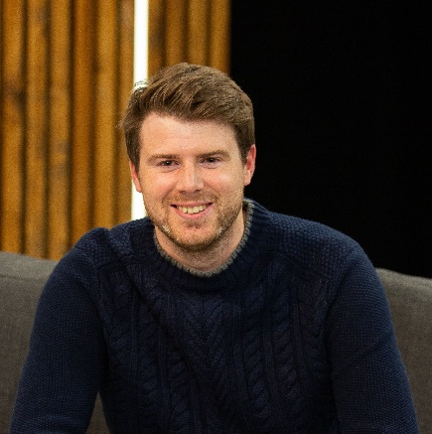
On behalf of Open Doors,

With love and blessings,


Dan G

Daniel Muwanguzi Mukiibi
Director SEAN UGANDA (TEE) and the SEAN International Regional coordinator for Africa.
Daniel and the SEAN Uganda Mission

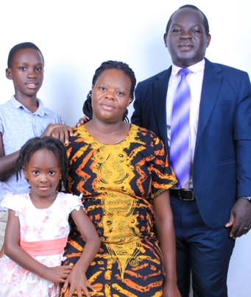
I am honoured to serve the SEAN vision in Uganda vision as the National Director as well as voluntarily serving as the SEAN International Africa coordinator (based in Uganda). SEAN Uganda (TEE) is a registered Non-Government Organisation (NGO). SEAN Uganda ministry has a registered vision of promoting Theological Education by Extension (TEE) in Uganda. This is our organisation “programme”. In this mandate, the mission is expected by the government (like other organisations) to promote Community transformation. This is our organisation “project”. Ndejje Resource Centre is the home of SEAN Uganda (TEE), where the organisation project is established.
Pastor Daniel with his wife Rebecca,
his 10 year-old son Genesis and 4 year-old daughter Elizabeth.
Rebecca volunteers with human resource management
at our organisation community medical centre

The SEAN Uganda discipleship and Evangelistic programme for making disciples.
The SEAN Uganda (TEE) programme promotes discipleship and evangelism in churches, on the remote islands, among many ignored refugee churches in Uganda (mainly from South Sudan and DR-Congo due to wars), and on the faraway Ssese Islands. The SEAN Uganda mission believes in working together with different partners in the gospel, to raise the next generation of discipled leaders in the Church of Christ. As for the Africa work, I voluntarily serve to inspire SEAN users in other African countries who seek to learn from the SEAN Uganda mission journey. I mainly work via Zoom and Microsoft Teams online meetings.

We serve different church denominations: Anglican, Baptist, Pentecostal and independent churches in line with fulfilling the great commission in Matthew 28:18-20.

Appreciating St Patricks’ warm welcome and Mission engagements.
Thank you for the prayer support all these years. We don’t take your prayers for granted as we long to see people evangelised and discipled in their local vicinities. Thank you for warmly loving and receiving me on the times I have visited St Patrick’s Church in Wallington. Truly I enjoyed preaching there and meeting and making many lovely friends at church. I also appreciate the prayer and pecuniary support to me and to the SEAN Uganda (TEE) mission work.
I look forward to visiting again this September.

pro DEO Baptist Church, Craiova, Romania
Led by Pastor Doru Tiulete

We exist to glorify God and to be part in His expending Kingdom.
Mission: leading the next generation into a growing relationship with Christ.
Vision: We are committed to creating relevant environments where previous generations can pour their lives into the next generations for Christ.

Highlights of 2024:
- Children outreach events (https://www.facebook.com/share/v/1AH84S8Qcj/): Egg Hunt, International Children Day, teens camp, students camp, Christmas night
- Our annual Church Retreat Outreach
- The baptism of Luca (my son), Iazmin and Diana
- Enjoying the use of the unfinished new building – we started to use it for our Christmas event in December and since them we never left it
- Our second international short term mission – Moldova

2024 was another blessed year for the pro DEO community
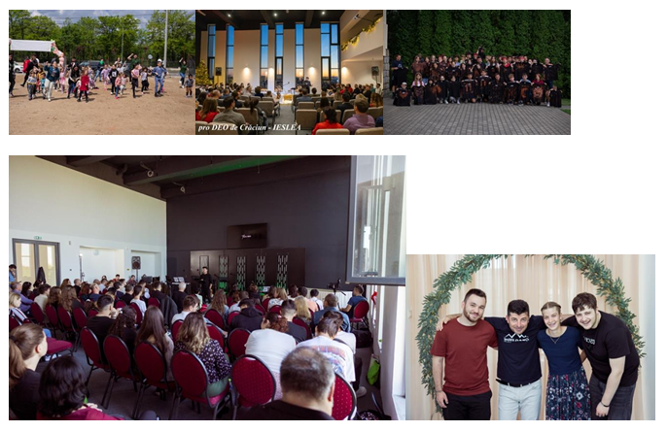
Pray with us for:

• that love for God and for those He loves will drive us in evangelism
• for teens and students that are attending our camps this year
• to finish the church building and to receive the operating permit from
the city hall and the fire department
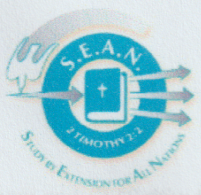
SEAN (Study by Extension in All Nations)

SEAN was created in South America in 1971 as a means of allowing Christians to study locally and in their mother tongue rather than leaving home to attend a Bible College with courses offered in an official language. It has expanded to include courses in 118 languages worldwide. Every year well over 200,000 people do SEAN Bible courses in more than 100 countries

As SEAN students study at home and serve in the local church, they grow and mature in their faith as well as discover and develop their gifts; thus, they are able to exercise a more effective ministry both in the Church and the community.
The courses are based on well-established educational techniques and are open to all. Those who have difficulty with reading or writing can work with another student to help them.

A typical SEAN course contains about 10 weekly units or lessons, each with two basic elements:

The home study is completed by the student at home prior to the group meeting. Interacting with their Bible and the study text, the student fills out the answers to the questions raised. The deceptively simple style and easily answered repetition is, in fact, carefully graded reinforcement of basic doctrines and facts.

The group meeting is led by a trained tutor who uses the leaders’ guide to build further on the home study making full use of small group dynamics that leads to practical and personal application of the truths learned. The group leader or tutor follows carefully set out goals and instruction for the meeting to ensure the concepts covered are fully grasped.

All SEAN courses seek to help people grow in their faith and to encourage them to apply what they learn in the mission and ministry of the church. They focus on equipping disciples as followers of Jesus Christ in this world who can pass on what they have learned to others and so take on leadership within their own churches at various levels. Our courses therefore combine study of the content of our faith with practical skills that are helpful for the growth of the church.

www.seanorganisation.org

Simon Ellingham
Sutton Schoolswork (SSW)
Supporting the delivery of Christianity within Religious Education in all schools in Sutton, and creating and enabling Christian Unions
Highlights!
SSW has had another extraordinary year. In the last 12 months we have started 5 brand new Christian Unions; delivered many different sessions in 8 secondary schools, opening doors in 2 previously non-engaging schools; expanded our Easter Experience to Year 4 pupils to 5 venues across 4 weeks, reaching over 2300 pupils and staff; increased our delivery of Discover Christmas, Transit, CSI Easter; and increased the number of primary schools that receive our assemblies to 38.
We’ve said goodbye to Charis, said hello to Maisie, and are shortly to say goodbye to Sarah! All this means that our new arrangement will be Maisie and Abby in charge of all primary work, Simon in charge of all secondary, as well as being the Director. We are, as always, wonderfully assisted by Petra in the office, and our numerous volunteers around the borough who give up their time to serve God by telling children and young people about their faith in Jesus.
A big thank you to our prayer partners, our financial supporters (both churches and individuals) and to our friends all across the country.

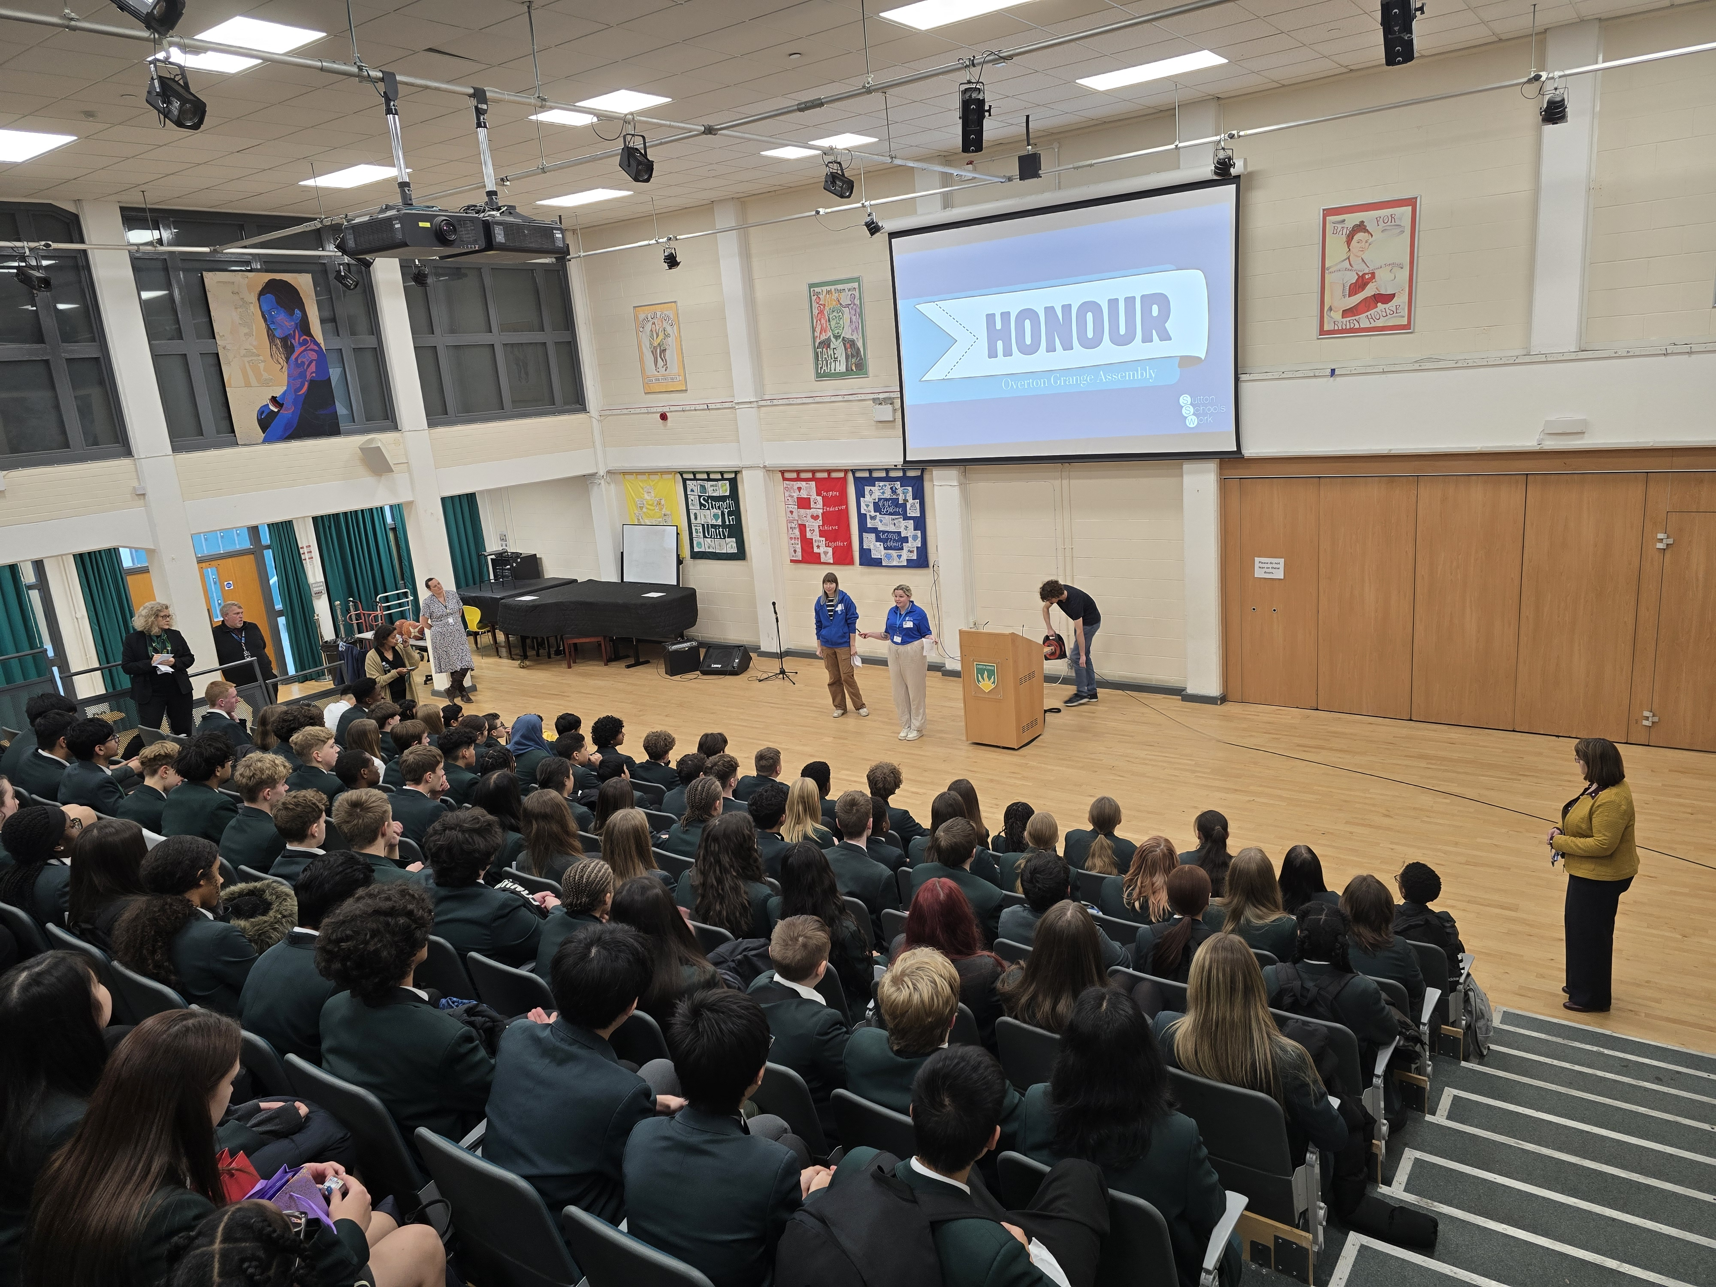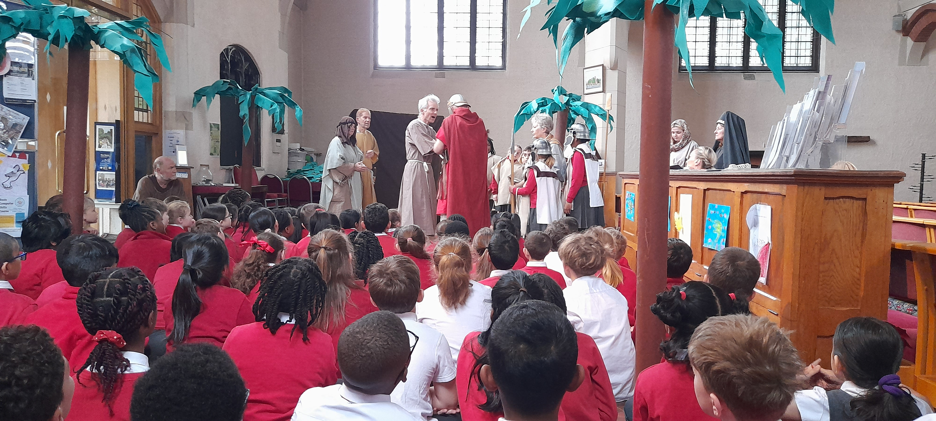
Prayer points –

19 schools have booked in for Transit, an extraordinary number. Please pray that we can meet this demand and deliver a quality workshop that tells them of God’s care and love.

Our new CUs, at Greenshaw and Carshalton Boys, which are showing signs of growth and maturity. Please pray that those who attend will find real faith and be encouraged to tell others of their wonderful God.

Our new programme for Primary schools commencing in September, which we are praying may see even more schools begin to participate.

For more information, please see our website suttonschoolswork.co.uk

Paul*

Formerly worked in South Asia*; now lives in Wallington but ministers to and advises some South Asian churches in the UK and visits South Asia once a year. Regular contact with Asian believers on WhatsApp & Facebook.

“Give and it will be given unto you” “It is more blessed to give than receive”

MEETING UP AFTER 53 YEARS!
God gave me the wonderful privilege of meeting up with Titus after 53 years! We had only occasionally texted each other on Facebook over the years. From 1970 - 73 my first job in South Asia was running a vegetable garden. Titus was the only child of his widowed mother, who was working for 2 of our Nurses who ran a Medical Clinic 1½ days walk from the town where I was living at the time. Titus was 18 (probably 1973) and had finished at school and wanted to learn typing in order to get a job in the District Centre where he lived so he came to learn to type. He had the money to pay for his tuition, but not for his food and accommodation. It was decided that he would earn his keep by working in my garden. After finishing the training, he returned home and got a job as a typist in the District Education Office and worked there for the next 39 years. Now living in the capital city he had noticed me when I was seeing the children of the family I was staying with, on to the school bus, but carried on his way. However, he couldn’t get it out of his head that it was me he had seen, so he returned to where the school bus had left, enquired with some of the locals as to where the family I had been with were living, and came and knocked on the door where I was staying!! We had ‘tato chai’ (tea) together and he told me all I have written above. He is still a committed believer and is a member of a large, local church in the capital city. God’s wonderful faithfulness!

SHIVA
She was in my teenager group in the late ‘90’s from a poor, low caste, Christian family. She reminded me, at church in March, that I had paid for her to do a computer course after leaving school and she had obtained employment after finishing the course. But, actually, it wasn’t me who paid for the course, although I physically handed over the money, but it was all of you! How? With the amazing support that you gave me from St Pats, including also from Missionary Mart and other individuals from St Pats, I was able to help my Asian brothers and sisters who needed finance for medicines, operations, trainings, passports, citizenship costs, etc. You have blessed the church through your giving to me and, also, through your faithful prayers over many years. I want to truly honour you and thank you. God’s wonderful faithfulness reaching across the world, giving glory to God! Amen!

Prayer points: 25 South Asian* Christians were arrested last year accused of persuading others to change their religion. This is prohibited by law. Some have been sentenced to 3 years in jail.

*Name changed
**Name of country has been withheld for security reasons

Partnering with Mission

We hope that you have enjoyed reading about our Mission Partners. The Mission Gift Day is a real opportunity to bless these individuals who have been so bold in serving God, by contributing financially to their needs. It is a great way to spend our money on something which will have an eternal effect.

If you would like to make a donation please contact office@stpats.org.uk



First page photo:
‘The Twelve Apostles’
Victoria, Australia

