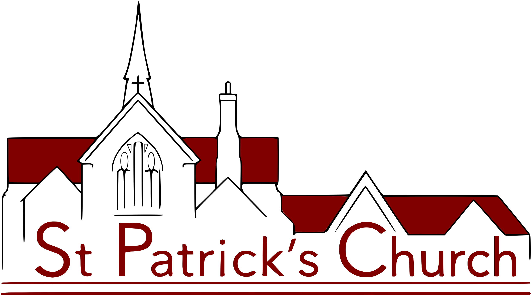
St Patrick’s Church
Park Hill Road
Wallington
Surrey SM6 0RQ

HEALTH AND SAFETY POLICY
For St Patrick’s Church

Introduction

As a church, we understand that we owe a duty of care to ensure the safety of those who use or visit our church or church centre.
We also know that, where we are an employer or control premises in certain circumstances, we have to meet the requirements of health and safety law.
In particular, we know that if we are an employer having five or more employees, we are required to have a written health and safety policy. At the time of this revision, we have fewer than five employees but we have decided to maintain our written policy. As such, we have drafted this policy to meet our duty under Section 2(3) of the Health and Safety at Work etc. Act 1974.

General statement of policy

Our policy is to ensure, so far as is reasonably practicable, that our activities are carried out safely and do not pose a risk to the health of our employees, volunteers, congregation, contractors and others who may use or visit the church, church grounds or church centre. This will be in accordance with good practice and any relevant statutory provisions where they apply.
The Parochial Church Council (PCC) accepts its overall responsibility for this.
We will endeavour to make available adequate resources in order to achieve this objective. Any decisions we make will have due regard for it.
The PCC will keep health and safety matters under review at appropriate intervals. We will monitor the effectiveness of the policy, amending it where we believe it is no longer valid.
It is the duty of each employee and volunteer to exercise personal responsibility for their own safety and that of others – and the success of this policy will depend on their cooperation. This policy will be brought to their attention and they will be asked to read it carefully.
Further detail about our organisation and arrangements for managing health and safety is set out in this document. A copy of it will be kept in the church, church centre and on the church website, and made available on request.

Signed: …………………………………………………………..
On behalf of the PCC as agreed at a meeting on

Date: ……………………………………………………………..

Organisation and Responsibilities

1. The member of the PCC with overall responsibility for implementing our policy is Vicar Ollie Osborn.
He will ensure that:
- The standards set out in this policy are implemented and maintained
- Where necessary, specialist health and safety assistance is obtained
- Arrangements are in place so that hazards reported are rectified as soon as practicable
- Only competent persons carry out repairs, modifications, inspections and tests
- Any accidents are investigated, recorded and reported if necessary
- Relevant health and safety documents and records are retained
- He keeps up to date on health and safety matters relevant to the church
- He sets a personal example on matters of health and safety

2. The Church Operations Manager, Ginny Drake, has day-to-day responsibility for implementing our policy. Our Churchwardens remain accountable for implementing our policy, they are Phil Goodchild and Sue Springate.
They will ensure that:
- All employees and volunteers are aware of their health and safety responsibilities
- Adequate precautions are taken as set out in this policy and related risk assessments
- Adequate information and training are provided for those that need it
- Any hazards or complaints are investigated and dealt with as soon as practicable
- Where defects cannot be corrected immediately, interim steps are taken to prevent danger
- All accidents are reported in-line with the requirements of this policy
- Specialist advice is sought where clarification is necessary on the implementation of this policy
- They set a personal example on matters of health and safety

3. All employees and volunteers have a responsibility to cooperate in the implementation of this policy and to take reasonable care of themselves and others while on church business or premises.
They will ensure that they:
- Read this policy and understand what is required of them
- Complete their work taking any necessary precautions to protect themselves and others
- Comply with any safety rules, operating instructions and other working procedures
- Report any hazard, defect or damage, so that this might be dealt with
- Warn any new employees or volunteers of known hazards
- Attend any training required to enable them to carry out their duties safely
- Do not undertake any repair or modification unless they are competent to do so
- Report any accident
- Do not misuse anything provided in the interests of health and safety

Arrangements

This section sets our general arrangements for managing health and safety and dealing with specific risks.

Accident Reporting
We will keep an accident book and record details therein. The accident book will be kept in the church centre, at the atrium service point. We will report to the relevant authority and keep records of certain accidents to employees, volunteers and members of the public in accordance with the Reporting of Injuries, Diseases and Dangerous Occurrences Regulations (RIDDOR).

Asbestos
We will take steps to identify the presence of asbestos in our buildings and, if asbestos is found, to assess any risk from it. We will then implement any plan to manage that risk. We will maintain an electronic asbestos register and make available any documents to those who might need them.

Church Building and Church Centre
We will ensure that the fabric of our buildings is regularly inspected to make sure it is safe and clean. Defects will be repaired as soon as is practicable bearing in mind that a faculty may be required. Where necessary, temporary measures will be taken to prevent danger until permanent repairs can be made.

Church grounds
We will ensure that boundary walls, fences, gates and paths are kept in good repair. We will have trees inspected by a competent person and have any necessary work carried out to make them safe.

Construction Work
Where maintenance, refurbishment and restoration work is planned for our church, we will identify what we need to do to ensure the safety of all those concerned before works starts. We will also determine if we have any responsibilities under the Construction (Design and Management) Regulations and comply with these if necessary.

Contractors
If we employ contractors, we will make sure that, where these are legally required, they have their own health and safety policy, Employers Liability insurance and Public Liability insurance by asking to see copies of the relevant documents.

Display Screen Equipment
Where our employees regularly use computers daily, for continuous periods of an hour or more, we will analyse workstations to identify precautions and discuss with employees how best to implement these as necessary.

Electricity
We will ensure that any electrical system, fixed machine and portable appliance is maintained so as to prevent danger. Any defective equipment will not be used until it is repaired or replaced. We will keep records of the checks made where appropriate.

Events
Where we intend to hold large services and events, we will identify any additional precautions that are necessary and implement these.

Fire Regulations
We will complete a specific risk assessment to identify what steps are necessary to prevent, detect, and take in the event of a fire in order to comply with fire regulations. We will record our findings, implementing any necessary mitigations.
We will review and revise these where we suspect that they are no longer valid.
We will ensure fire exits are clearly signposted and adequate firefighting equipment is available and maintained.

First Aid
We will provide suitably stocked first aid kits and a person who will take charge of first aid arrangements. We will also provide relevant information for employees and volunteers. First aid boxes are located:
Church building – In the kitchenette by the south door
Church centre – One at the atrium service point; another in the kitchen
Our person in charge of replenishing first aid boxes is: Becca Murrihy.
Our person in charge of first aid arrangements is: Church Operations Manager, Ginny Drake.

Hazardous Substances
We only use domestic cleaning or horticultural products. We will ensure that these are stored, used and disposed of in accordance with the manufacturers’ instructions.

Heating Systems
We will ensure that any gas heating system is suitably maintained and checked annually by a competent person. Any defects found will be corrected immediately and we will keep records of the checks made.

Information and Training
We will provide any necessary information and training for our employees and volunteers in a timely manner. We will keep a record of what is provided.
We will also give relevant information to contractors and self-employed people who may need this to complete their work safely.

Lift in Church Centre
We will ensure that the lift is properly maintained and thoroughly examined periodically by a competent person.

Manual Handling
We will avoid the need for lifting or carrying heavy objects as far as possible.
Where this is not practical, we will make use of lifting aids (such as trolleys) or take other precautions including team lifting.

Monitoring
We will make periodic checks to ensure that our precautions remain effective and adequate. We will ensure that the lift in the church centre is working. We will inspect electrical equipment and utilities as necessary to ensure that they remain safe. We will keep records of the checks we make.

Preparation of Food
We will ensure that on those occasions when we prepare food, we use a clean and disinfected work surface, utensils and equipment. We will store food in such a way to avoid contamination, provide hand-washing facilities and suitable arrangements for the disposal of waste.

Record Keeping
Our Health and Safety Risk Assessments and associated documents are kept in electronic files accessible to the Vicar, Churchwardens, Church Operations Manager and other individuals as they deem appropriate.

Risk Assessments
We will complete risk assessments to identify what we need to do to comply with health and safety law. We will record our findings, implementing any necessary mitigations. We will review and revise these where we suspect that they are no longer valid.

Slips and Trips
We will implement suitable precautions to prevent slips and trips, taking account of any difficulty the frail, elderly or disabled may have in negotiating access. We will make periodic checks to ensure floors, coverings, steps and pathways remain in good condition, free from obstruction and that any precautions (such as handrails or lighting) remain adequate. We will correct any defects identified. We will have arrangements in place to manage pathways in winter weather.

Work Equipment
Any work equipment we provide will be suitable, in good condition and properly maintained. Where necessary, some equipment (such as ladders and scaffold tower) will be periodically checked to make sure they are safe.

Working Alone
We will identify circumstances where our employees and volunteers work alone and implement suitable precautions to ensure their safety. See separate Lone Working Policy document.

Working at Height
Where possible, we will try to avoid the need for work at height. Where this is not practicable, we will ensure that any work is properly planned to identify suitable precautions.

